Directories Submission:
 | URL | 360 travel Screenshot | studentadventuretours Screenshot
1 | https://www.9sites.net/submit.php  https://www.9sites.net/submit.php | 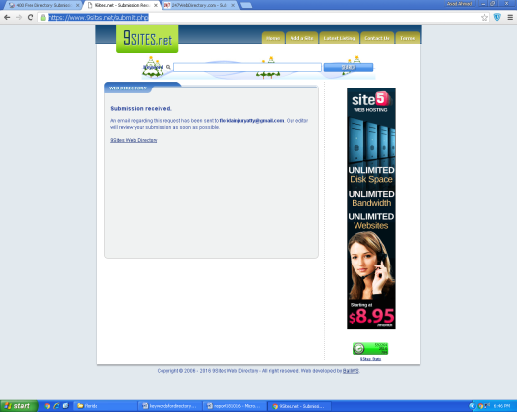 | 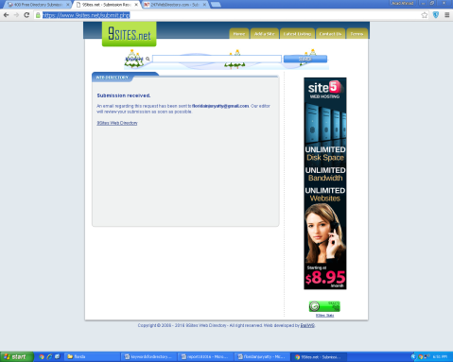
2 | http://www.247webdirectory.com/save.aspx  http://www.247webdirectory.com/save.aspx | 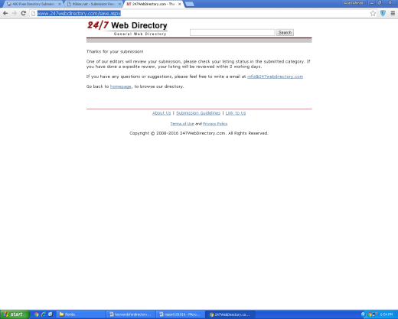 | 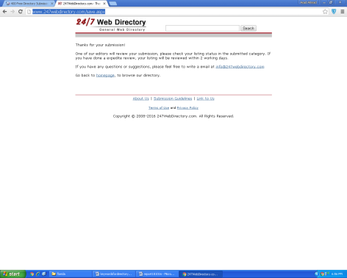
3 | http://www.a1webdirectory.org/submit?c=424&LINK_TYPE=1  http://www.a1webdirectory.org/submit?c=424&LINK_TYPE=1 | 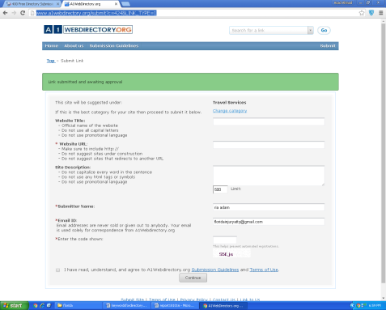 | 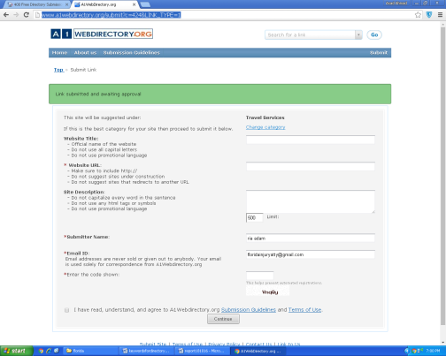
4 | http://www.abacusseo.com/submit.php  http://www.abacusseo.com/submit.php | 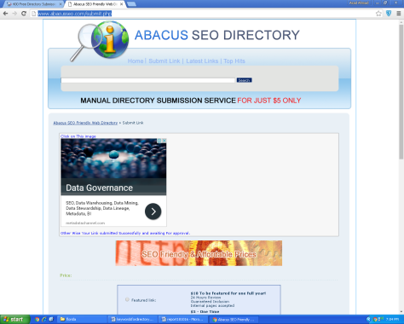 | 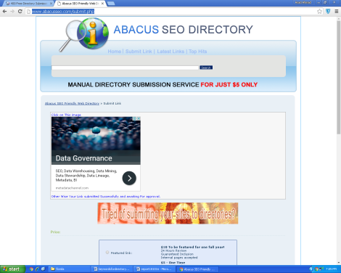
5 | http://www.abstractdirectory.com/  http://www.abstractdirectory.com/ | 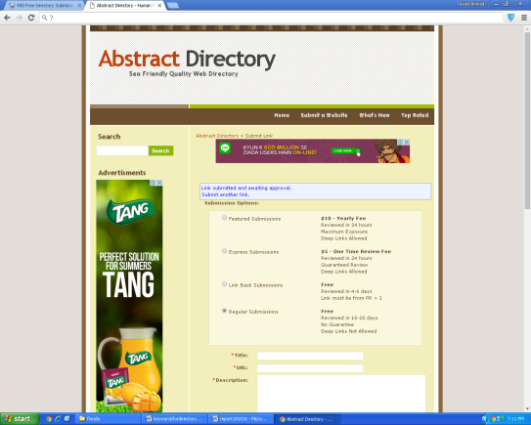 | 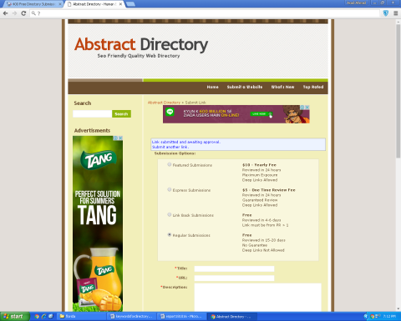
6 | http://www.acewebdirectory.com/add_data.aspx  http://www.acewebdirectory.com/add_data.aspx | 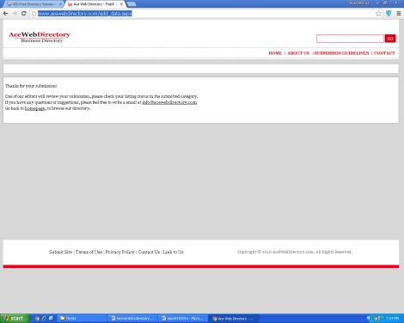 | 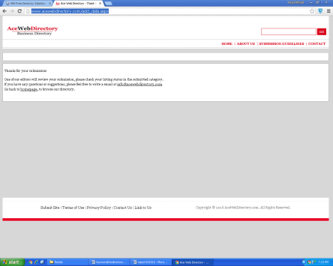
7 | http://www.addbusiness.net/submit.php?c=784&LINK_TYPE=1  http://www.addbusiness.net/submit.php?c=784&LINK_TYPE=1 | 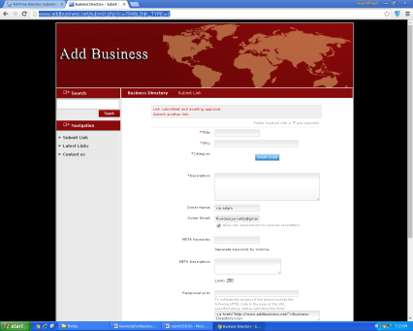 | 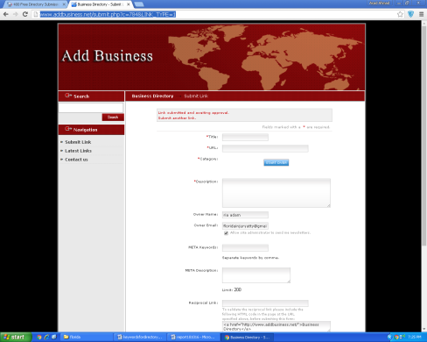
8 | http://www.adgaz.biz/submit.php?c=1&LINK_TYPE=1  http://www.adgaz.biz/submit.php?c=1&LINK_TYPE=1 | 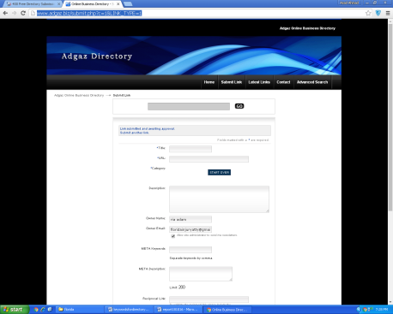 | 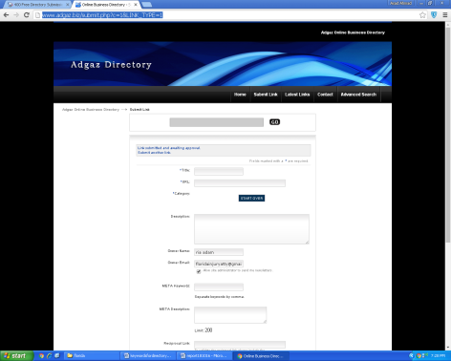
9 | http://www.alistdirectory.com/submit.php  http://www.alistdirectory.com/submit.php | 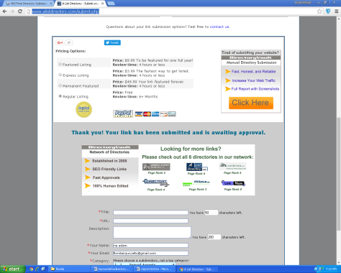 | 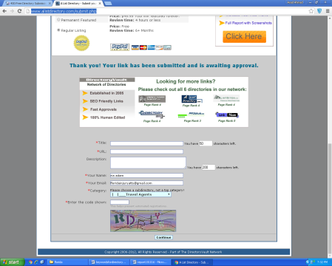
10 | http://www.allnicesites.com/submit.php#submit  http://www.allnicesites.com/submit.php#submit | 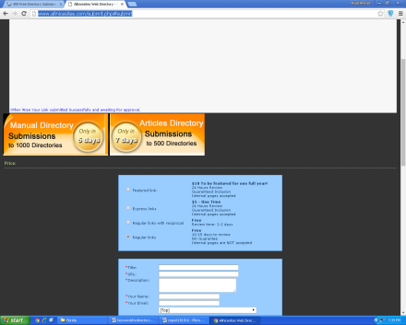 | 